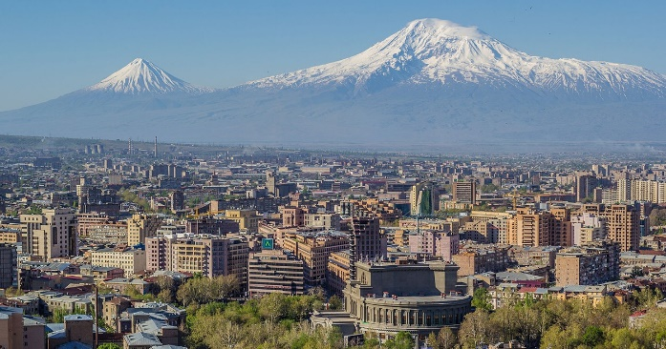

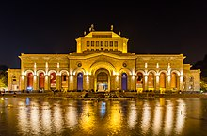

Joint Conference
ICOM International Committee for the Training of Personnel (ICTOP)
ICOM International Committee on Ethical Dilemmas (IC ETHICS)
ICOM ARMENIA and History Museum of Armenia

October 23-26, 2024
Yerevan, Armenia

CALL FOR PAPERS

Museum Professionalism and Ethics in Challenging Times

ICTOP and IC ETHICS are happy to announce a joint conference in cooperation with ICOM Armenia, the History Museum of Armenia, and the Ministry of Education, Science, Culture and Sports of Armenia dedicated to the 105th anniversary of the History Museum of Armenia and its founding director Yervand Lalayan’s 160 anniversary.

We are living in a complex world where global issues like climate change, pandemics, decolonization, war, polarization and inequality affect our lives. These global crises inevitably affect museums and the way they contribute to society. The new museum definition, approved by the Extraordinary General Assembly of ICOM in Prague on 24 August 2022, reflects the changing perspectives on this role of museums:

A museum is a not-for-profit, permanent institution in the service of society that researches, collects, conserves, interprets and exhibits tangible and intangible heritage. Open to the public, accessible and inclusive, museums foster diversity and sustainability. They operate and communicate ethically, professionally and with the participation of communities, offering varied experiences for education, enjoyment, reflection and knowledge sharing.

In this conference, we want to further explore the terms ‘ethically’ and ‘professionally’ in relation to global crises. What does it mean to act professionally? What ethical dilemmas do we face in this context? How can we best prepare museum professionals for these complex challenges?

The changes in society force museum professionals to adopt a new attitude towards their audiences. The museum professional is constantly evolving to meet the shifting needs and expectations of the 21st century. Getting a grip on how the role of a museum professional shapes our daily practice is essential for fostering accountability within the museum sector and advocating for the importance of ethical professionalism. Therefore, education and ethics play a critical role in ensuring the museum’s relevance and its impact in this changing world. They provide the foundational knowledge, practical skills, ethical grounding, and critical perspective needed to contribute to the mission of museums in serving communities and preserving cultural heritage in challenging times today and tomorrow.

We invite museum professionals, professors/lecturers in museology and related subjects, students in museum studies and other heritage professionals (ICOM and non-ICOM members) to share their experiences, case studies, practice, thoughts, research and ideas for finding answers to these questions of topics:

- How do current developments in society affect your institution?
- How can we prepare museum professionals for ethical dilemmas in situations of crises?
- What kinds of skills are valuable in the 21st century or specific in situations of crises?
- In what way do we find our professionalism under threat in times of crises?
- What ethical dilemmas do you face?

We accept abstracts on Collection care, Audience, (re)Presentation and Collecting that help to find new ways and approaches to future professional and ethical development in the museum field. Your contribution could be in the form of a

presentation/paper (15-20 minutes)
workshop (1 hour)
poster (as part of a poster session)

Please note that selected papers will be published in a special volume of the History Museum of Armenian periodical.

Please submit your abstract (250 to 350 words maximum) and short biography (maximum 150 words) by July 1st, 2024. The announcement of approved proposals is August 1st, 2024.
The following information should be included in the abstract:
- Name(s) of Author(s) / or workshop leader(s)
- Affiliation(s) & full address(es)
- Title of submitted paper & type of presentation
- Abstract in English (250 to 350 words maximum)
- Support equipment required (if any)
- Short bio/CV of presenter(s) (no more than 150 words)
- Please label your filenames with your surname and ICTOP2024.
- Font: Arial Unicode.
Abstract submissions should be sent before 1st of July 2024 as a MS Word, or PDF attachment to ICOM-ICTOP and ICOM ETHICS Yerevan 2024 Program Committee:
icom.2024.yerevan@gmail.com
Please attach to the mail as CC the following emails:
Chair.icethics@icom.museum
cykwon@gmail.com

